Experiment No -1

AIM: - To implement 4 bit ALU for Add,Substract, AND,NAND,OR,XOR,XNOR using VHDL.

OBJECTIVE: - To study concurrent statements in VHDL and behavior of ALU.
SOFTWARE: Xilinx ISE 13.4
THEORY: -
VHDL code is inherently concurrent (parallel). Only statements placed inside a process, function, or procedure are sequential. Concurrent code is also called dataflow code. Purely concurrent code cannot be used to implement synchronous circuits (except guarded block). In other words, in general we can only build combinational logic circuits with concurrent code. To obtain sequential logic circuit, sequential code must be employed. In this experiment, we will discuss concurrent statements. They are the WHEN statements and GENERATE. Besides them, assignments using only operators (logical, arithmetic, etc) can be obviously also be used to create combinational circuits. Finally, a special kind of statements, called BLOCK, can also be employed.
In summary, in concurrent code the following can be used:
1. Operators.
2. The WHEN statements (WHEN/ELSE or WITH/SELECT/WHEN).
3. The GENERATE statements.
4. The BLOCK statements.
As mentioned above, WHEN is one of the fundamental concurrent statements. It appears in two forms WHEN/ELSE (simple form) or WITH/SELECT/WHEN (selected form).
WHEN/ELSE
signal_name <= expression_1 when condition_1 else
expression_2 when condition_2 else
expression_3 ;

WITH/SELECT/WHEN
with identifier select
signal_name <= expression_1 when value,
expression_2 when value,
expression_3 when others;

NOTE: Whenever WITH/SELECT/WHEN is used, all permutation must be tested, so the keyword OTHERS is often useful. Another important keyword is UNAFFECTED, which should be used when no action is to take place.
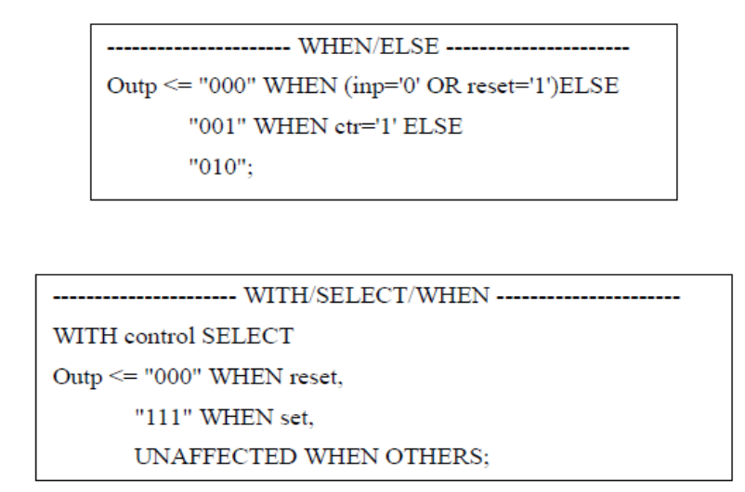
Arithmetic Logic Unit:
An arithmetic logic unit (ALU) is a digital electronic circuit that performs arithmetic and bitwise logical operations on integer binary numbers. It is a fundamental building block of the central processing unit (CPU) found in many computers. The inputs to an ALU are the data to be operated on (called operands) and a code indicating the operation to be performed; the ALU's output is the result of the performed operation.
4 bit ALU:
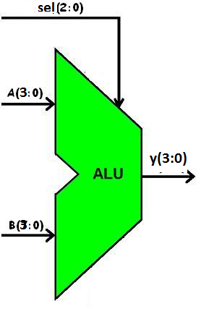
Truth Table:
S2 | S1 | S0 | Y
0 | 0 | 0 | a + b
0 | 0 | 1 | a - b
0 | 1 | 0 | a and b
0 | 1 | 1 | a nand b
1 | 0 | 0 | a xor b
1 | 0 | 1 | a xnor b
1 | 1 | 0 | a or b
1 | 1 | 1 | a (alu pass)

VHDL Program:
library IEEE;
use IEEE.STD_LOGIC_1164.ALL;
use IEEE.STD_LOGIC_ARITH.ALL;
use IEEE.STD_LOGIC_UNSIGNED.ALL;
entity alu is
Port ( a,b : in STD_LOGIC_VECTOR (03 downto 0);
sel : in STD_LOGIC_VECTOR (02 downto 0);
y : out STD_LOGIC_VECTOR (03 downto 0));
end alu;
architecture Behavioral of alu is
begin
With sel select
y<= a + b when "000",
a - b when "001",
a nand b when "010",
a and b when "011",
a or b when "100",
a xor b when "101",
a xnor b when "110",
a when others;
end Behavioral;

VHDL Testbench:
LIBRARY ieee;
USE ieee.std_logic_1164.ALL;
USE ieee.std_logic_unsigned.all;
USE ieee.numeric_std.ALL;
ENTITY test_vhd IS
END test_vhd;
ARCHITECTURE behavior OF test_vhd IS

COMPONENT alu
PORT(
a : IN std_logic_vector(3 downto 0);
b : IN std_logic_vector(3 downto 0);
sel : IN std_logic_vector(2 downto 0);
y : OUT std_logic_vector(3 downto 0)
);
END COMPONENT;

SIGNAL a : std_logic_vector(3 downto 0) := (others=>'0');
SIGNAL b : std_logic_vector(3 downto 0) := (others=>'0');
SIGNAL sel : std_logic_vector(2 downto 0) := (others=>'0');

SIGNAL y : std_logic_vector(3 downto 0);

BEGIN

uut: alu PORT MAP(a => a,b => b, sel => sel,y => y );

tb : PROCESS
BEGIN
sel<="011";
a<="0001";
b<="1001";
wait for 10 ns;
sel<="100";
wait for 10 ns;
sel<="001";
wait for 10 ns;
sel<="111";
wait for 10 ns;
END PROCESS;

END;
Testbench Waveform Generated:
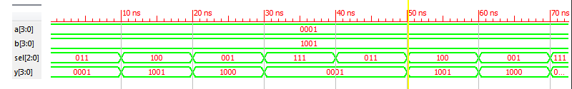

Conclusion:

